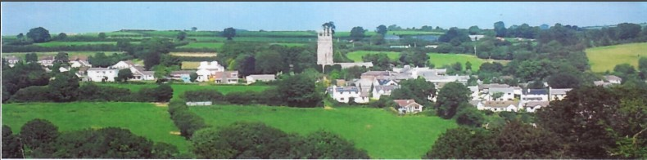

29th December 2024

Dear Councillor,

You are summoned to attend a meeting of North Hill Parish Council on Monday 6th January 2025 at 7.30pm in the Village Hall.

Please find attached the agenda for our meeting. We ask that if any member of the public has issues, they would like to raise that they contact the clerk prior to the meeting so that we can best manage them.

Please remember that the time allotted for Matters of Community Concern is not a forum to discuss what has taken place during this meeting and that any matter raised here would likely be added to the NEXT meeting agenda for discussion.

Yours faithfully,

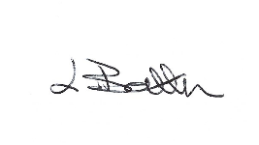

Lena Batten, Clerk to the Council

Members of the public are welcome to attend the meeting. However, we would like those attending to register prior to the meeting by emailing the Parish Clerk. Email: [northhillparishcouncil@btinternet.com](mailto:northhillparishcouncil@btinternet.com)

**AGENDA**

1. TO RECEIVE APOLOGIES:
2. CODE OF CONDUCT : a) TO RECEIVE DECLARATIONS b) TO GRANT DISPENSATIONS:

3. PUBLIC COMMENTS ON ITEMS ON THE AGENDA ONLY:

4. TO RECEIVE AND APPROVE THE MINUTES OF THE 2nd DECEMBER 2025 FULL COUNCIL MEETING:

5. ANY MATTERS ARISING FROM PAST MINUTES NOT ON THE CURRENT AGENDA:

6. TO CONSIDER PLANNING APPLICATIONS RECEIVED FROM CORNWALL COUNCIL BY DATE OF THIS MEETING:

6.1 To note for information - PA24/08862 - Tregood Farm Bodmin Road Congdons Shop Launceston PL15 7PN - Prior approval for change of use of two agricultural buildings to 2no dwellinghouses.

6.2 To note for information - PA24/08898 - Land South East Of Drogeada Close Drogeada Close Coads Green Launceston PL15 7LU - Prior notification of agricultural or forestry development for new fodder and machinery store.

6.3 To note for information - PA24/05278 - Penhallow Chapel Lane North Hill Launceston Cornwall PL15 7PQ - Proposal Demolition of existing wooden carport and replacement with single-storey extension,construction of a single-storey extension to the side and rear of the dwelling, installation of solar panels and other associated works - approved.

6.4 To note for information - PA24/08770 - Tuckers Garage Coads Green Launceston Cornwall PL15 7LY -

Proposal Submission of details to discharge Condition number 2 in respect of Decision Notice PA23/00832 dated 21/06/24.

6.5 PA24/08849 – Berrio Cottage, North Hill, PL15 7NL – Listed building consent for proposal to remove and relay the existing roof which is suffering from nail fatigue and allowing water ingress – comments submitted to confirm North Hill Parish Council had no objection.

6.6 To note for information – PA24/08082 - The Agricultural Barn, Hallicombe Farm, Bathpool, PL15 7NP – Prior approval for change of use to a single dwellinghouse and operational development not required.

7. ANY APPLICATIONS RECEIVED BEFORE THE DATE OF THIS MEETING: None to date.

8. TO REVIEW CORRESPONDENCE AND TO AGREED RESPONSES REQUIRED:

8.1 To accept feedback from Cllr R. Hudson regarding Voice Over telecommunication resilience.

8.2 To note for information that the clerk has sent a letter to Miss Elsie Crane to say thankyou for

sounding the post on Remembrance Day 2024.

8.3 To consider email regarding a vote of no confidence in Cornwall Council Planning Enforcement.

8.4 To note for information that Kompan failed to complete a playground check in November and have

Kept next years inspections x 3 2025 at the same price, a total of £385.41 in the way of apology.

Clerk completed a visual check prior to Christmas and confirmed that all work completed in the play

Area is covered under handyman insurance. Next check is booked for January 2025.

8 5 To consider / resolve next steps if the trailer in NHVH has not been removed by 6th January 2025.

8.6 To agree any response to the A388 Road Safety Campaign request.

9. TO REVIEW DETAILS FOR NORTH HILL PARISH COUNCIL CEMETERY:

Currently no details to review, Cemetery Committee will arrange a further meeting for early spring.

10. APPROVAL OF THE LIST OF PAYMENTS / RECEIPTS FOR DECEMBER 2024 & TO RECEIVE DECEMBER 2024 BANK STATEMENT:

10.1 AUTHORISATION OF EXPENSES INCLUDING SALARY:

i) £18.00 (PAYE G. Pollard payroll December, dd)

ii) £759.20 (Lena Batten, December salary / tax)

iii) £43.64 (room rent)

iv) £135.00 (Hire of machinery, Cllr D. Daniells)

v) £313.20 (Whitehall, purchase of new display case for Trebartha)

vi) £54.00 (Western Web, repairs to laptop)

vii) £259.04 (Mole Valley Farmers, purchase of new gate and accessories to fit)

10.2 RECEIPTS: £970.22 (LMP grant).

10..3 To receive bank statement:

Bank Statement as of 28th December 2024 £17,271.31

11. TO REVIEW MONTHLY BUDGET RECONCILIATIONS:

11.1 Budget Sheet Attached.

12. TO REVIEW MONTHLY RAG: (Red, Amber, Green)

12.1 RAG Sheet attached.

13. REPORT FROM CORNWALL COUNCIL WARD MEMBER COUNCILLOR PARSONS:

14. ITEMS FOR INCLUSION AT THE NEXT MEETING:

15. DATE & TIME OF NEXT MEETING:

16. CLOSE OF BUSINESS: